

## Project Report on “SMART CLASSROOM”

submitted in partial fulfillment of the requirement for the completion of VI semester of

**BACHELOR OF ENGINEERING**

**in**

**ELECTRONICS & COMMUNICATION ENGINEERING**

**Submitted by**

Girisha V B (1SI20EC401) Kusuma N (1SI20EC405) Mounika C R (1SI20EC407)

Shivakumara H (1SI20EC409)

under the guidance of **Mrs.T O Geetha Rani** Associate professor Department of E&CE SIT, Tumakuru-03

**DEPARTMENT OF ELECTRONICS & COMMUNICATION ENGINEERING 2021-22**

**DEPARTMENT OF ELECTRONICS & COMMUNICATION ENGINEERING**



**CERTIFICATE**

Certified that the mini project work entitled “SMART CLASSROOM” is a bonafide work carried out by GIRISHA V B (1SI20EC401), KUSUMA N (1SI20EC405), MOUNIKA

C R (1SI20EC407) and SHIVAKUMARA H (1SI20EC409) in partial fulfillment for the completion of VI Semester of Bachelor of Engineering in Electronics & Communication Engineering from Siddaganga Institute of Technology, an autonomous institute under Visvesvaraya Technological University, Belagavi during the academic year 2021-22. It is certified that all corrections/suggestions indicated for internal assessment have been in- corporated in the report deposited in the department library. The Mini project report has been approved as it satisfies the academic requirements in respect of project work prescribed for the Bachelor of Engineering degree.

Mrs.T O Geetha Rani Head of the Department

Associate professor Dept. of E&CE

Dept. of E&CE SIT,Tumakuru-03

SIT,Tumakuru-03

### External viva:

**Names of the Examiners Signature with date 1.**

**2.**

## ACKNOWLEDGEMENT

We offer our humble pranams at the lotus feet of **His** Holiness, **Dr. Sree Sree Sivaku- mara Swamigalu**, Founder President and **His** Holiness, **Sree Sree Siddalinga Swami- galu**, President, Sree Siddaganga Education Society, Sree Siddaganga Math for bestowing upon their blessings.

We deem it as a privilege to thank **Dr. M N Channabasappa**, Director, SIT, Tu- makuru, **Dr. Shivakumaraiah**, CEO, SIT, Tumakuru, and **Dr. S V Dinesh**, Princi- pal, SIT, Tumakuru for fostering an excellent academic environment in this institution, which made this endeavor fruitful.

We would like to express our sincere gratitude to **Dr. R Kumaraswamy**, Professor and Head, Department of E&CE, SIT, Tumakuru for his encouragement and valuable suggestions.

We thank our guide **Mrs. T O Geetharani**, Associate Professor, Department of Elec- tronics & Communication Engineering, SIT, Tumakuru for the valuable guidance, advice and encouragement.

Girisha V B (1SI20EC401) Kusuma N (1SI20EC405) Mounika C R (1SI20EC407)

Shivakumara H (1SI20EC409)

## Course Outcomes

CO 1 : Identify , formulate the problem and define the objectives

CO 2 : Review the literature and provide efficient design solution with appropriate con- sideration for societal, health and safety issues

CO 3 : Select the engineering tools/components and develop an experimental setup to validate the design

CO 4 : Test, analyse and interpret the results of the experiments in compliance with the defined objectives

CO 5 : Document as per the standard, present effectively the work following professional ethics and interact with target group

CO 6 : Contribute to the team, lead the diverse team, demonstrating engineering and management principles

### CO-PO Mapping

|  |  |  |  |  |  |  |  |  |  |  |  |  |  |  |
| --- | --- | --- | --- | --- | --- | --- | --- | --- | --- | --- | --- | --- | --- | --- |
|  | PO1 | PO2 | PO3 | PO4 | PO5 | PO6 | PO7 | PO8 | PO9 | PO10 | PO11 | PO12 | PSO1 | PSO2 |
| CO-1 | 3 |  |  |  |  |  |  |  |  |  |  |  | 3 |  |
| CO-2 |  | 2 |  |  |  | 1 |  |  |  |  |  |  | 2 | 1 |
| CO-3 |  |  | 2 |  | 2 |  |  |  |  |  |  | 2 | 2 | 2 |
| CO-4 |  |  |  | 2 |  |  |  |  |  |  |  |  |  | 2 |
| CO-5 |  |  |  |  |  |  |  | 2 |  | 2 |  | 2 |  | 2 |
| CO-6 |  |  |  |  |  |  |  |  | 2 |  | 1 |  |  | 1 |
| Average | 3 | 2 | 2 | 2 | 2 | 1 |  | 2 | 2 | 2 | 1 | 2 | 2 | 2 |

Attainment level: - 1: Slight (low) 2: Moderate (medium) 3: Substantial (high)

POs: PO1: Engineering Knowledge, PO2: Problem analysis, PO3: Design/Development of solutions, PO4: Conduct investigations of complex problems, PO5: Modern tool us- age, PO6: Engineer and society, PO7: Environment and sustainability, PO8: Ethics, PO9: Individual and team work, PO10: Communication, PO11: Project management and finance, PO12: Lifelong learning

Electricity has become necessity for all, without which day-to-day life chores and daily activities cannot be completed. Nowadays the wastage of electricity has become a major problem, human became too busy and they are unable to find time to turn off lights and fans when it’s not required.

The wastage of electricity is more in schools and colleges because normally students forget to switch off the lights and fans and also during the class hours cleaning the board is time consuming and absorbing the dust are the major problems, Hence there is a need of system to monitor all these activities to save power and time.

The aim of smart classroom is to control the classroom lights automatically depending on the number of students in the classroom and also to control the fan depending on the room temperature. It also cleans the white board automatically whenever the switch is activated.

Two Ultrasonic sensors at the entrance of the classroom senses whenever students enters, also the counter gets incremented and it turns ON the first light, if the number of students becomes more than five it turns ON the second light and so on, Similarly when students exit the class the counter decrements and when number of students in the classroom is less than five the second light turns OFF and so on. The DHT-11 temperature sensor senses the room temperature and whenever it exceeds the threshold value and if any student is present in the classroom then only it turns ON the fan. When the switch gets activated the dc motor turns on and the duster cleans the white board. Arduino reads the signal from all the sensors and sends the control signal to lights and fans.

i

|  |  |
| --- | --- |
| **Abstract**  **List of Figures**  **1 Introduction** | **i**  **ii 1** |
| 1.1 Motivation . . . . . . . . . . . . . . . . . . . . . . . . . . . . . . . . . . . . | 1 |
| 1.2 Objective of the project . . . . . . . . . . . . . . . . . . . . . . . . . . . . | 1 |
| 1.3 Organisation of the report . . . . . . . . . . . . . . . . . . . . . . . . . . . | 1 |
| **2 Literature Survey** | **3** |
| **3 Block diagram of Smart classroom** | **5** |
| **4 System Hardware** | **7** |
| 4.1 Ultrasonic sensor(HC-SR04) . . . . . . . . . . . . . . . . . . . . . . . . . . | 7 |
| 4.2 Relay . . . . . . . . . . . . . . . . . . . . . . . . . . . . . . . . . . . . . . . | 8 |
| 4.3 Buzzer . . . . . . . . . . . . . . . . . . . . . . . . . . . . . . . . . . . . . . | 8 |
| 4.4 Temperature sensor . . . . . . . . . . . . . . . . . . . . . . . . . . . . . . . | 9 |
| 4.5 LCD display . . . . . . . . . . . . . . . . . . . . . . . . . . . . . . . . . . . | 10 |
| 4.6 Motor driver(L293D) . . . . . . . . . . . . . . . . . . . . . . . . . . . . . . | 10 |
| 4.7 Circuit diagram of Smart classroom . . . . . . . . . . . . . . . . . . . . . . | 11 |
| **5 System Software** | **13** |
| 5.1 Arduino IDE . . . . . . . . . . . . . . . . . . . . . . . . . . . . . . . . . . | 13 |
| 5.2 Algorithm . . . . . . . . . . . . . . . . . . . . . . . . . . . . . . . . . . . . | 13 |
| 5.3 Flowchart . . . . . . . . . . . . . . . . . . . . . . . . . . . . . . . . . . . . | 14 |
| **6 Results** | **15** |
| 6.1 Automatic light control system . . . . . . . . . . . . . . . . . . . . . . . . | 16 |
| 6.2 Automatic fan control system . . . . . . . . . . . . . . . . . . . . . . . . . | 17 |
| 6.3 Automatic board cleaning . . . . . . . . . . . . . . . . . . . . . . . . . . . | 18 |

1. Conclusion 19
   1. Scope for future work 19

Bibliography 19

Appendices 21

A Data Sheet of Arduino 22

1. DataSheet of Relays 24
2. Data Sheet of Ultrasonic Sensor 25
3. Data Sheet of Motor driver (L293D) 26
4. Data Sheet of Buzzer 27

|  |  |  |
| --- | --- | --- |
| 3.1 | Block diagram of smart classroom. . . . . . . . . . . . . . . . . . . . . . . | 5 |
| 4.1 | Ultrasonic sensor interfacing. . . . . . . . . . . . . . . . . . . . . . . . . . . | 7 |
| 4.2 | Relay Interfacing. . . . . . . . . . . . . . . . . . . . . . . . . . . . . . . . . | 8 |
| 4.3 | Buzzer Interfacing. . . . . . . . . . . . . . . . . . . . . . . . . . . . . . . . | 9 |
| 4.4 | Temperature sensor Interfacing. . . . . . . . . . . . . . . . . . . . . . . . . | 9 |
| 4.5 | LCD display Interfacing. . . . . . . . . . . . . . . . . . . . . . . . . . . . . | 10 |
| 4.6 | Motor driver Interfacing. . . . . . . . . . . . . . . . . . . . . . . . . . . . . | 11 |
| 4.7 | Smart classroom Interfacing. . . . . . . . . . . . . . . . . . . . . . . . . . . | 11 |
| 5.1 | Arduino IDE. . . . . . . . . . . . . . . . . . . . . . . . . . . . . . . . . . . | 13 |
| 5.2 | Flowchart of smart classroom. . . . . . . . . . . . . . . . . . . . . . . . . . | 14 |
| 6.1 | Smart classroom. . . . . . . . . . . . . . . . . . . . . . . . . . . . . . . . . | 15 |
| 6.2 | Snapshots of Automatic light control system . . . . . . . . . . . . . . . . . | 17 |
| 6.3 | Before board cleaning. . . . . . . . . . . . . . . . . . . . . . . . . . . . . . | 18 |
| 6.4 | After board cleaning. . . . . . . . . . . . . . . . . . . . . . . . . . . . . . . | 18 |
| A.1 | Arduino UNO. . . . . . . . . . . . . . . . . . . . . . . . . . . . . . . . . . | 22 |
| B.1 | Relays. . . . . . . . . . . . . . . . . . . . . . . . . . . . . . . . . . . . . . . | 24 |
| C.1 | Ultrasonic Sensor. . . . . . . . . . . . . . . . . . . . . . . . . . . . . . . . . | 25 |
| D.1 | L293D. . . . . . . . . . . . . . . . . . . . . . . . . . . . . . . . . . . . . . . | 26 |
| E.1 | Buzzer. . . . . . . . . . . . . . . . . . . . . . . . . . . . . . . . . . . . . . . | 27 |

# Introduction

## Motivation

Wastage of electricity is one of the main problems which we are facing nowadays. In our home, school, colleges, or industry we see that fans/lights are kept on even if there is nobody in the room or area/passage. This happens due to negligence or because we forgot to turn lights off or when we are in a hurry. During class hours cleaning the board is time-consuming and absorbing dust are a major disadvantage, to controlling the lights of a classroom automatically based on the number of students in a classroom. If five students are in the classroom only one light will be turned on, if more than five students another light will be turned on using sensors. The LDR (Light Dependent Resistor) is used to sense the weather condition. The system can identify the bright or dark environment using LDR. The weather is dark the system allows to ON the classroom lights. The weather is bright the system allows to OFF the classroom lights and also fan inside the classroom is automatically controlled as the temperature of the device increases or decreases and the speed of the fan increases or decreases respectively. An automatic whiteboard cleaner is designed by switching a button, the board will be automatically erased with the help of a duster fixed in a way to erase the whiteboard efficiently.

## Objective of the project

The main objectives of the project are:

1. To control the lights of classroom automatically based on the number of students in the classroom.
2. To control the fan automatically depending on room temperature.
3. To design and implement automatic white board erasing system.

## Organisation of the report

The report is divided into 7 chapters. Chapter 1 gives the introduction of the proposed project. Chapter 2 discusses the literature survey. Chapter 3 presents the system overview

Smart Classroom 2021-22

of the smart classroom. Chapter 4 explains the hardware used in the system. chapter 5 discusses the software used in the proposed system. Chapter 6 and 7 discusses the results and conclusion of the project respectively.

# Chapter 2

**Literature Survey**

The mechanism of the automated board cleaner entails a horizontal motion. The duster which spans horizontally across the width of the board is to clean the board. The design is such that when the switch is turned on, the motor transmits energy which turns the shaft which in turn, drives the pulley. The duster is fixed to the pulley chains which move to and fro (horizontal motion) along its plane, thereby cleaning the board[1].

DHT11 is uses as capacitive humidity sensor and a thermistor to measure the surrounding air, and gives out a digital signal. It requires careful timing to grab data. It gives new data once every 2 seconds, so when using our library, sensor reading date is two second hold. Simply connect the first pin on the left to 3-5V power, the second pin to data input pin and the rightmost pin to ground. It uses a single-wire to send data. The output of DHT11 is feed to the Arduino Uno board in pin no 12. The Arduino Uno is connected to the 16x2 LCD display[2].

The lead screw is used to convert rotary motion into translation motion. The screw jack is a device used for lifting the load with the application of small force. The mechanical advantage of screw jack is the ratio of the load applied to the effort applied. The screw jack is operated by turning a lead screw of jack. The effort required to operate the screw is eliminated by using 12 V DC Motor. The motor operates by 12V DC power sup- ply which is drawn from the vehicle battery itself. The rotary motion transfer from the motor to lead screw through worm gear drive. The driver gear (pinion) located on the mo- tor shaft and the driven gear located on the lead screw causes to transfer rotary motion[3].

Automatic Light Intensity Control using Arduino UNO and LDR gives the idea of auto- matic lightning system and peculiar way of implementation with embedded tool systems. This method is used to measure and control the intensity of light in room. This technique is implemented with help of LDR’s, microprocessor and IRF520 MOSFET driver module

Smart Classroom 2021-22

to measure as well as to control the intensity of light as per the requirement of the user. In this project four LDR’s are placed at four different corners of the room precisely taken care for blockage of light. The required intensity of light is obtained by taking the average of all four LDR’s and compared with the reference intensity of the light as specified by the user. Accordingly, the whole intensity of the room is adjusted by using the MOSFET, it stepup the Arduino voltage to a value able to drive some higher loads. This system reduces the power consumption as well as eye strain for the user to execute the smart work in real time application[4].

Automatic Street Light Control by Detecting Vehicle Movement gives the idea of detect- ing motion. The work is to have two controls like, one is to switch OFF lights during no vehicle moments in streets and automatically switch it ON whenever vehicles arrive. The LED lights are used for street arrangement, the Photo diodes and IR sensors are used to sense vehicle moments. The control signals of sensors have been fed to microcontroller 8051. In the microcontroller the control logic is implemented to control lights with bright and dim mode of operation based on vehicles and pedestrian moments and to switch off lights during no vehicles and pedestrian. By this method the overall energy has being utilized now-a-days for lighting can be minimized[5].

The several researchers work on it, the latest research was about the applications effective for the positioning of transparent objects that measure and identify the objects like a glass bottle (transparent objects). The author has discussed an ultrasonic object location and shape perception system that can reach the distance intention in both width and depth directionally, step by step using sound signals sensor of an ultrasonic[6].

The basic idea behind the project is to conserve the amount of power which is otherwise wasted in case of absence of an entity or human behaviors. The system will restrict the turning ON/OFF of the lights utilizing sunlight entering the room and turning ON/OFF the fan automatically based on the temperature detected. The design gives the user its flexibility to choose the modes of operation either automated that is based on sensors or just the conventional switching[7].

# Chapter 3

**Block diagram of Smart classroom**

This chapter discusses the block diagram of Smart classroom.

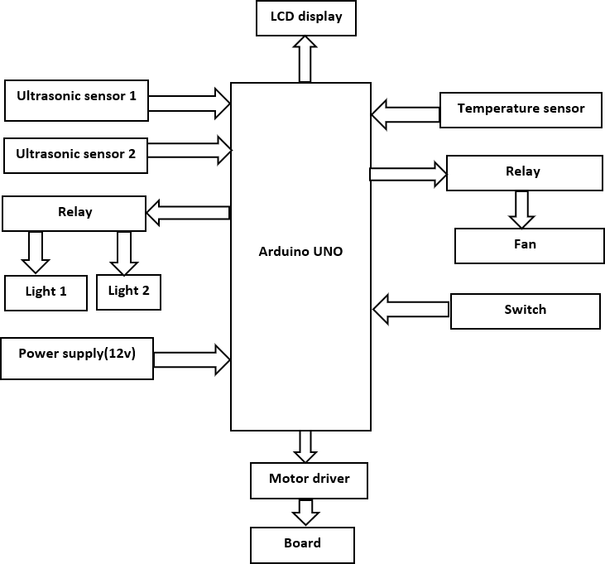

Figure 3.1: Block diagram of smart classroom.

Figure 3.1. Shows the block diagram of the Smart classroom. The main aim of the project is to save the electricity and time of humans automatically in the classroom. To control the classroom lights automatically depending on the number of students in the classroom and also to control the fan depending on the room temperature. It also cleans the whiteboard automatically whenever the switch is activated. The Ultrasonic sensor at the entrance of the classroom senses whenever students enter, also the counter gets

Smart Classroom 2021-22

incremented and it turns ON the first light if the number of students becomes more than five it turns ON the second light and so on similarly when students exit the class the counter decrements. When the number of students in the classroom is less than six the second light turns OFF and so on. The temperature sensor senses the room temperature and whenever it exceeds the threshold value it turns ON the fan. When the switch gets activated the dc motor turns on and the duster cleans the whiteboard. Arduino reads the signal from all the sensors and sends the control signal to lights and fans.

# Chapter 4

**System Hardware**

This chapter describes about the hardware components used in the project and interfacing the components with Arduino UNO.

## Ultrasonic sensor(HC-SR04)

Ultrasonic sensors emit short, high-frequency sound pulses at regular intervals. These propagate in the air at the velocity of sound. If they strike an object, then they are reflected as an echo signal to the sensor, which itself computes the distance to the target based on the time duration between emitting the signal and receiving the echo. Two ultrasonic sensors are used in a project to detect the motion and each sensor has a delay of 500ms, Ultrasonic sensor sends the data to the Arduino when the motion is detected within the range of 20mm to 2m of distance.

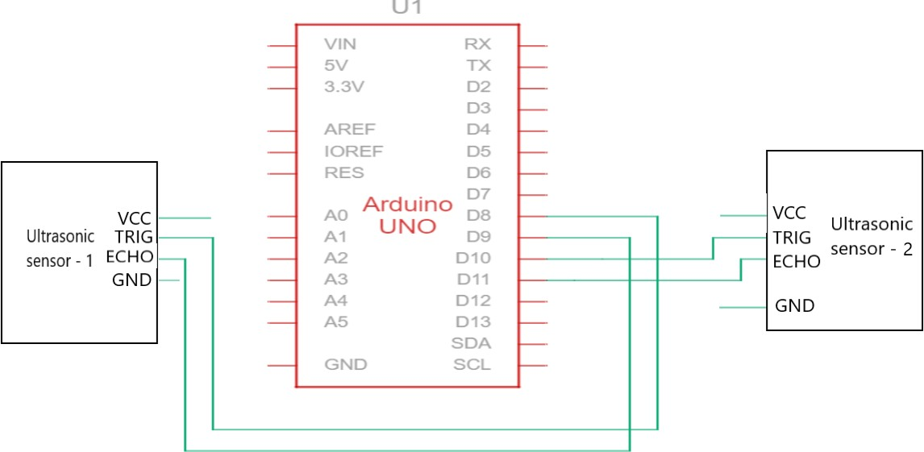

Figure 4.1: Ultrasonic sensor interfacing.

## Relay

A Relay is an electromechanical device that uses an electric current to open or close the contacts of a switch. Since this project is designed with two lights. The dual-channel relay module is required for controlling two lights, two-channel relay comprises components that make switching and connection easier and act as indicators to show if the module is powered and if the relay is active or not. Relays are the switches that open and close circuits electromechanically or electronically. In this circuit Relay Module is connected to Arduino, when the ultrasonic sensor detects the presence of the student it sends the signal to the Arduino, So the Arduino decides which Realy to trigger depending on the number of students present inside the classroom to turn ON the lights.

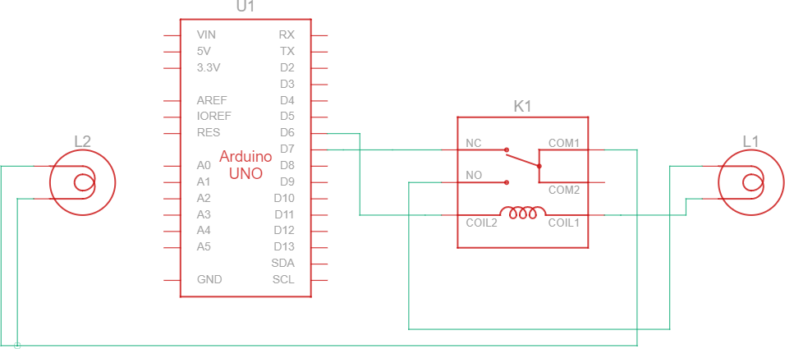

Figure 4.2: Relay Interfacing.

## Buzzer

A Buzzer is an audio signaling device, which may be mechanical, electromechanical, or piezoelectric. Typical uses of buzzers include alarm devices, timers, training, and confir- mation of user input such as mouse click or keystroke. It works on a 5V supply. Whenever a person enters the classroom Arduino sends a signal to the buzzer and it will turn ON the buzzer for 5 seconds.

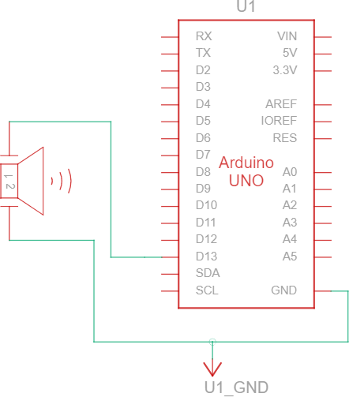

Figure 4.3: Buzzer Interfacing.

## Temperature sensor

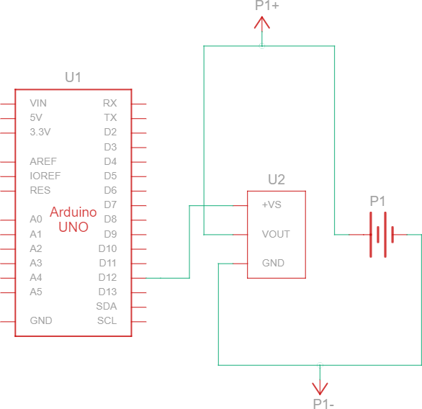The temperature sensor converts the surrounding temperature to voltage and sends it to Arduino. It further converts the voltage from Fahrenheit to Celcius, and displays it on the LCD screen. DHT-11 is the temperature sensor used in this project which is of low voltage, the purpose of usage of this temperature sensor in this project is to control the fan automatically based on the room temperature.

Figure 4.4: Temperature sensor Interfacing.

## LCD display

The 16×2 LCD is an electronic device used to display the message and data. In this project LCD is used to count and display the number of students entering and leaving the

classroom. This means that if a person enters the classroom the counter will be increased and if they depart counter decreased. The room temperature will be displayed on LCD.

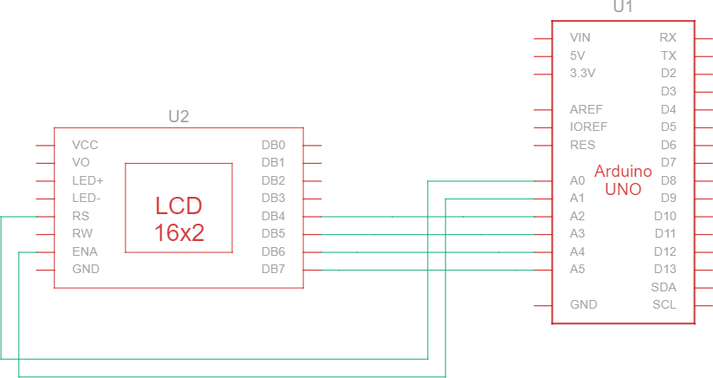

Figure 4.5: LCD display Interfacing.

## Motor driver(L293D)

The L293D is a 16-pin motor driver IC which can control a set of two DC motors simul- taneously in any direction. The L293D is designed to provide bidirectional drive currents of up to 600mA at voltages from 4.5V to 36V. The motor driver is connected to Arduino, When the switch is turned ON, the motors start working so the duster slide moves front and back to erase the written data on the board. The screw jack technique is used to operate this circuit. A lead screw is used to convert rotational motion into translational motion. It is connected to the switch and power supply of an Arduino. A lead screw is used to convert rotational motion into linear motion.

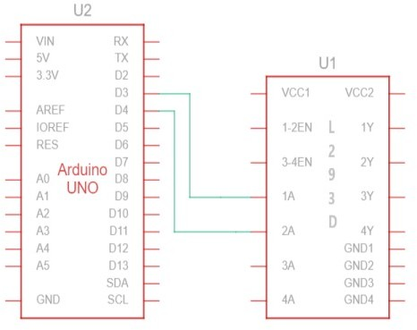

Figure 4.6: Motor driver Interfacing.

## Circuit diagram of Smart classroom

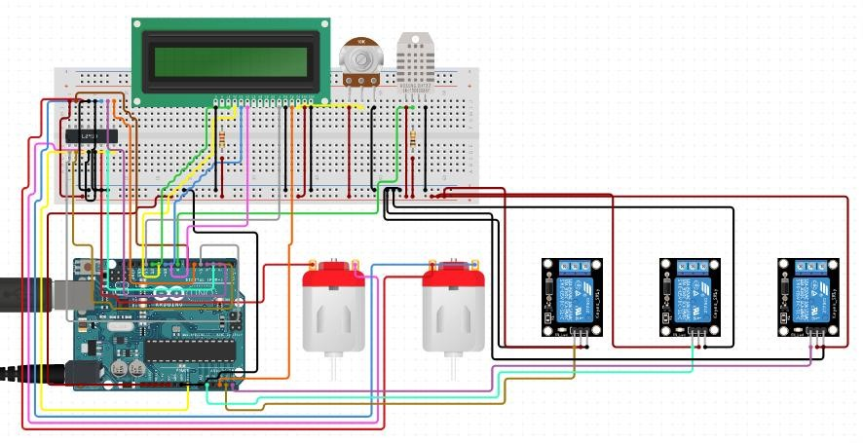

Figure 4.7: Smart classroom Interfacing.

Arduino UNO is a microcontroller board based on the ATmega328. It has 20 digital

input/output pins (of which 6 can be used as PWM outputs and 6 can be used as analog inputs), a 16MHz resonator, a USB connection, a power jack, in-circuit system program- ming (ICSP) header, and a reset button. Arduino is an open-source electronics platform based on easy-to-use hardware and software. The Arduino board reads the input data from the ultrasonic sensor and it is used to record the data based on the data read by the ultrasonic sensor. If a person enters inside the classroom an ultrasonic sensor senses the motion and it sends signal to Arduino. Arduino sends a signal to realy to turn ON the light and the count is displayed on the LCD display. The temperature sensor sense the room temperature and sends the data to the Arduino depending on the temperature, based on the temperature fan turns ON/OFF by switching the relay. L293D is a basic motor driver IC that is connected to the Arduino that enables to drive a dc motor in either direction by using screw jack principle. A lead screw is used to convert rotational motion into linear motion. It is connected to the switch and power supply of an Arduino. so that the whiteboard can be erased once switched ON.

# Chapter 5 System Software

## Arduino IDE

Arduino IDE stands for Arduino Integrated Development Environment. It is a cross- platform application (for Windows, macOS, and Linux) that is written in functions from C and C++. It contains a text editor for writing code, a message area, a text console, a toolbar with buttons for common functions, and a series of menus. It connects to the Arduino hardware to upload programs and communicate with them. Arduino IDE is shown in the Figure 5.1. The C language is used for coding.

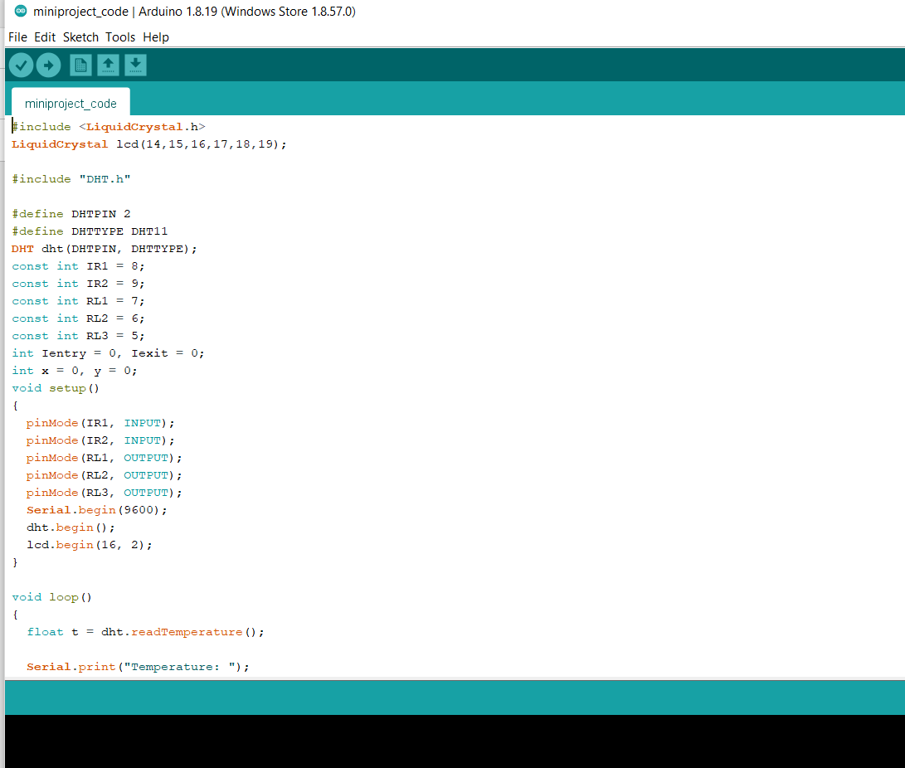

Figure 5.1: Arduino IDE.

## Algorithm

Start reading the data from sensors. If any motion inside the classroom is detected by the ultrasonic sensor then it sends data to the Arduino. Arduino reads data from the sensor and counts the entries of the students entering the classroom where the number of counts is displayed on the LCD. The model we developed is consisting of two ultrasonic

Smart Classroom 2021-22

sensors and a single DC fan. The first sensor is placed outside the door and the second one is placed inside so when a person crosses both the ultrasonic sensor then the buzzer produces a beeping noise indicating that the student has entered inside and the first light is turned ON. Similarly When the number of counts is exceeded by 5 members then the second light is turned ON. A Fan is turned ON depending on the room temperature and it is turned ON only in the presence of humans inside the classrooms.

## Flowchart

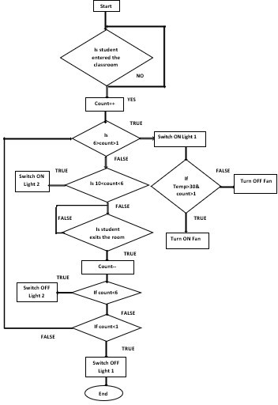

Figure 5.2: Flowchart of smart classroom.

# Chapter 6

**Results**

The designed Smart classroom that consists of different components such as Arduino UNO, DHT-11 sensor, Temperature relay, Relay, Buzzer, Bulbs, DC Motor, L293D motor driver, LCD, Ultrasonic sensor etc....

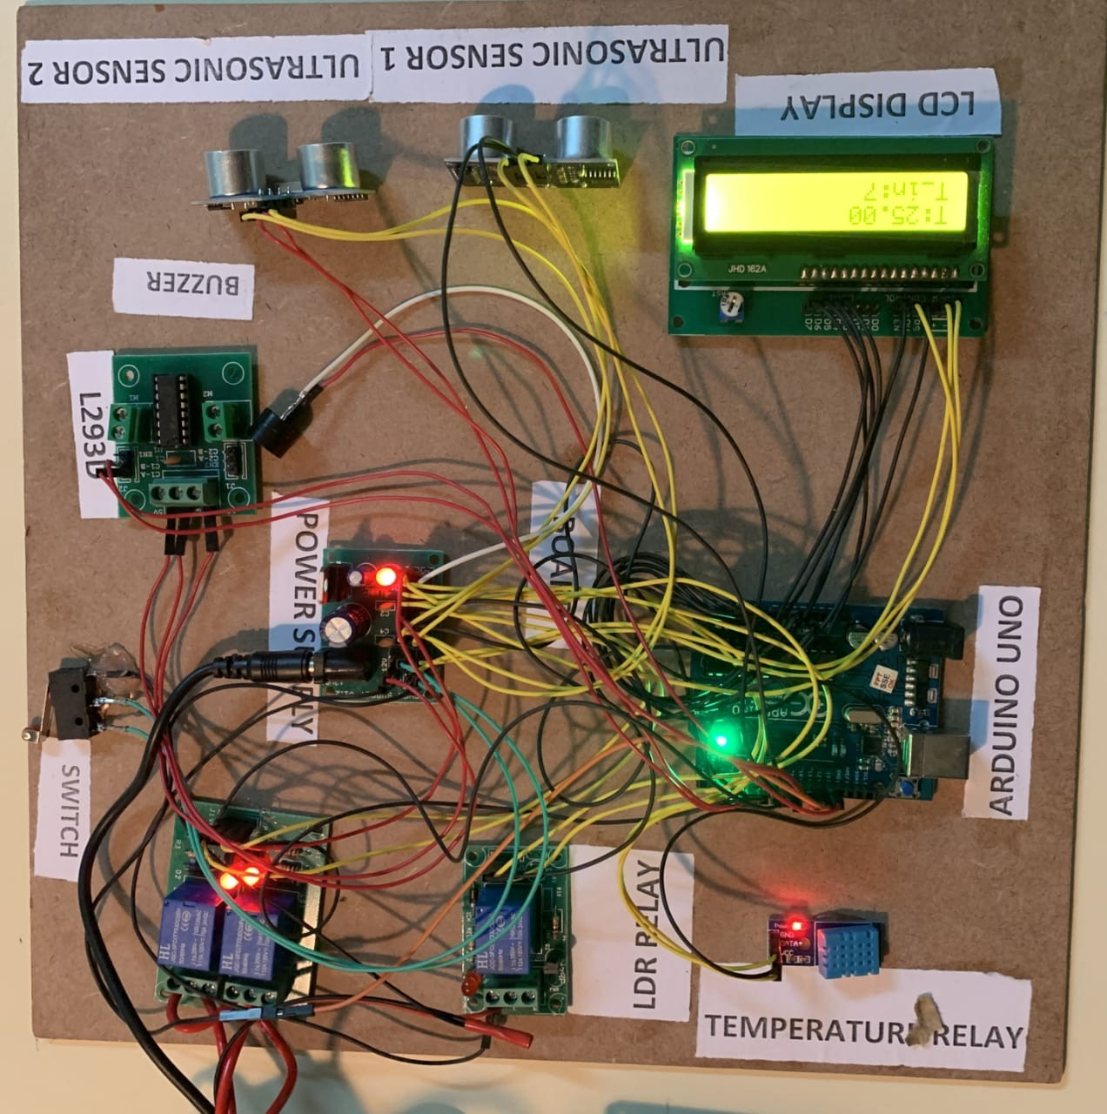

Figure 6.1: Smart classroom.

The real-time implementation of the Smart classroom System is done in library, SIT. Whenever a motion is detected by the Ultrasonic sensor at the entrance it senses and also the counter gets incremented and it turns ON the first light, when the number of students becomes more than five it turns on the second light as shown in the Figure 6.2. Similarly when students exit the class the counter decrements when the number of students in the classroom is less than five the second light turns OFF. The DHT-11 temperature sensor senses the room temperature, whenever it exceeds the threshold value and if any presence of a human is detected then the only fan turns ON as shown in Figure 6.3. When the

switch gets activated the dc motor turns ON and the duster cleans the whiteboard as shown in Figure 6.5. Arduino reads the signal from all the sensors and sends the control signal to lights and the fan.

## Automatic light control system

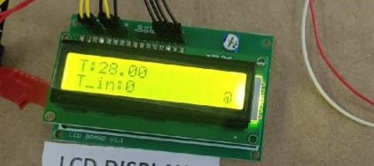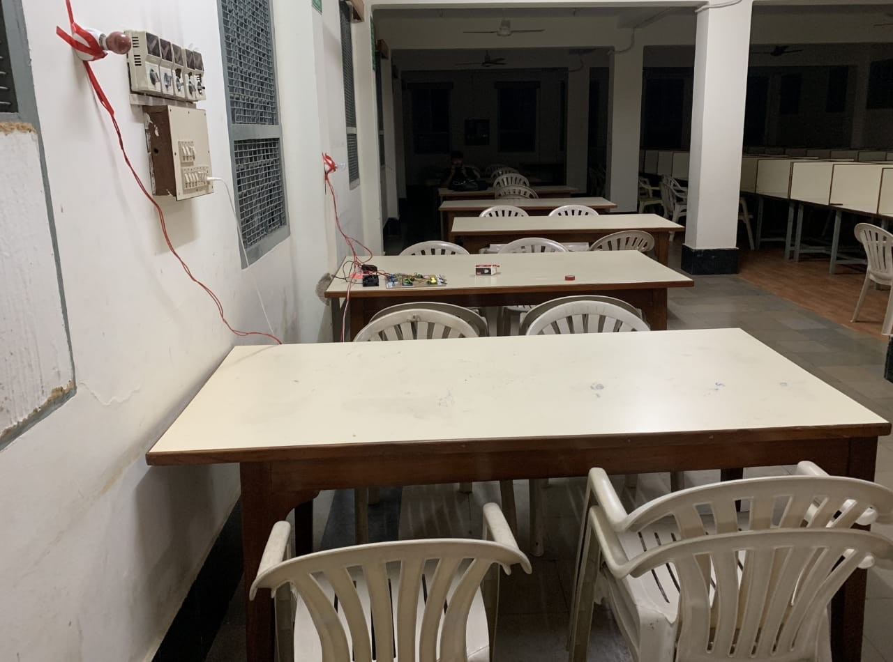

* + 1. When the classroom is empty (b) Both the lights switched OFF

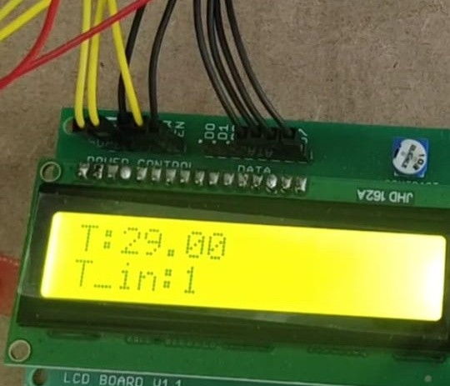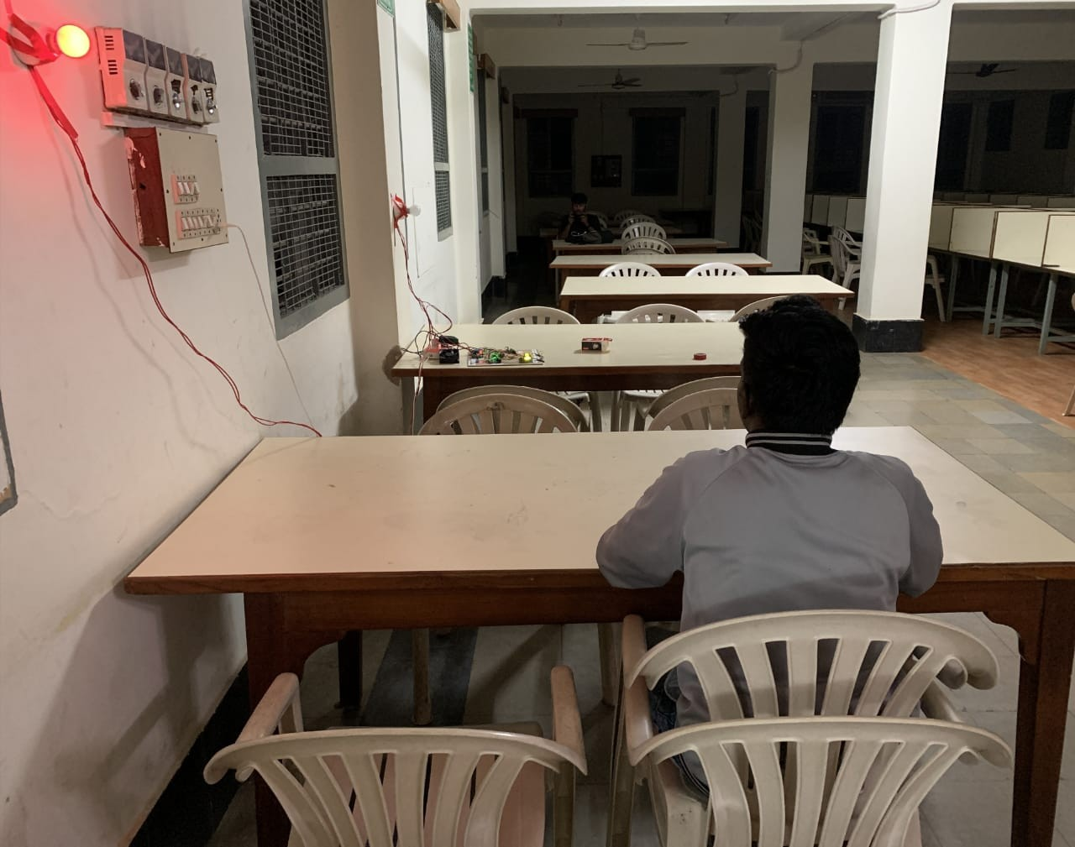

(a) When a person enters the classroom (b) First light switched ON

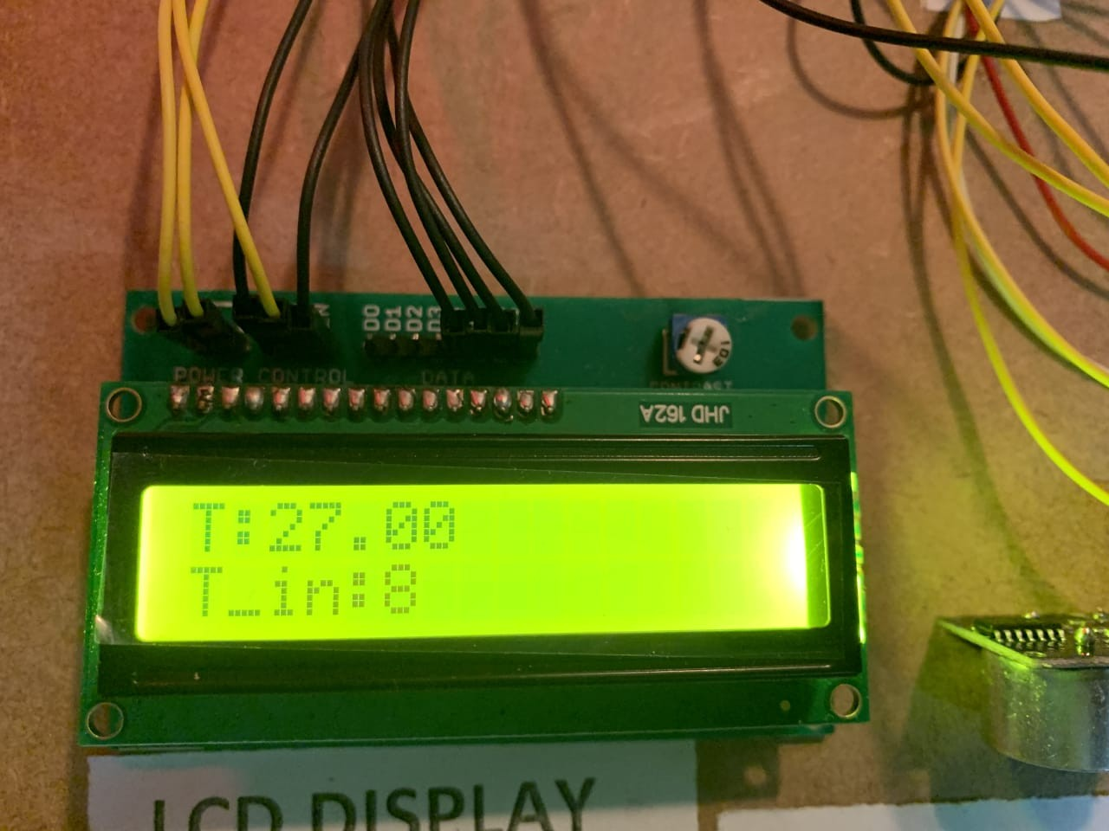 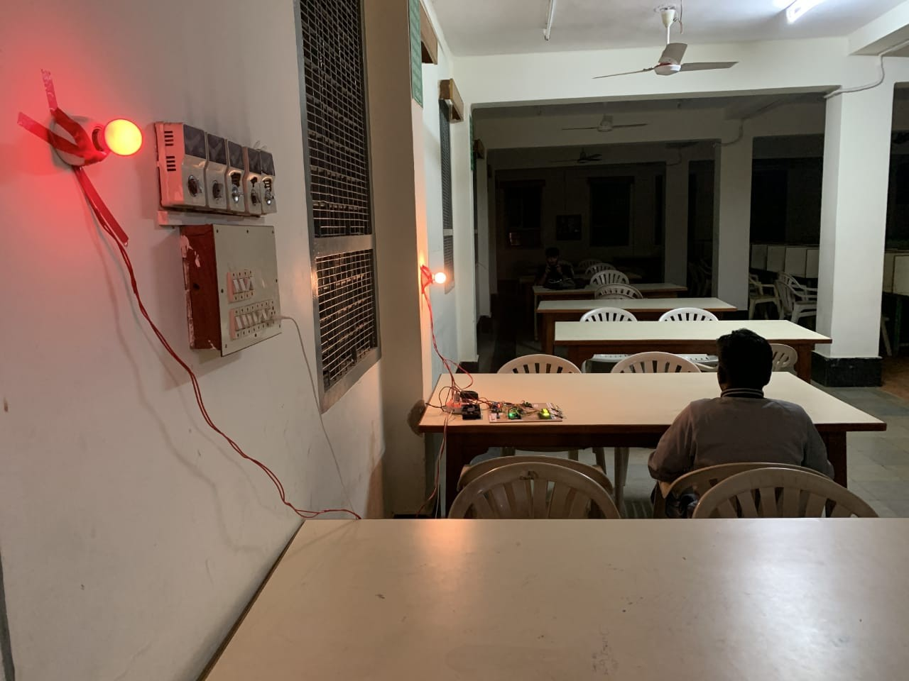

(a) More than five persons are present. (b) Both the lights switched ON Figure 6.2: Snapshots of Automatic light control system

## Automatic fan control system

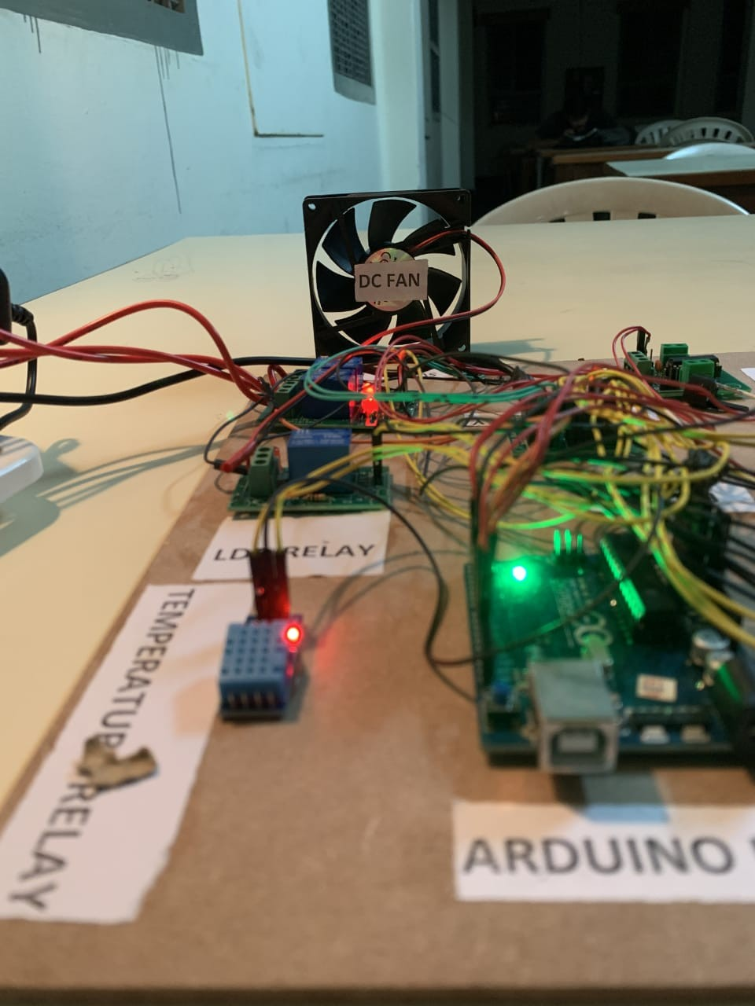

* + 1. When temperature is lesser than 30 degree (b) Fan is OFF state

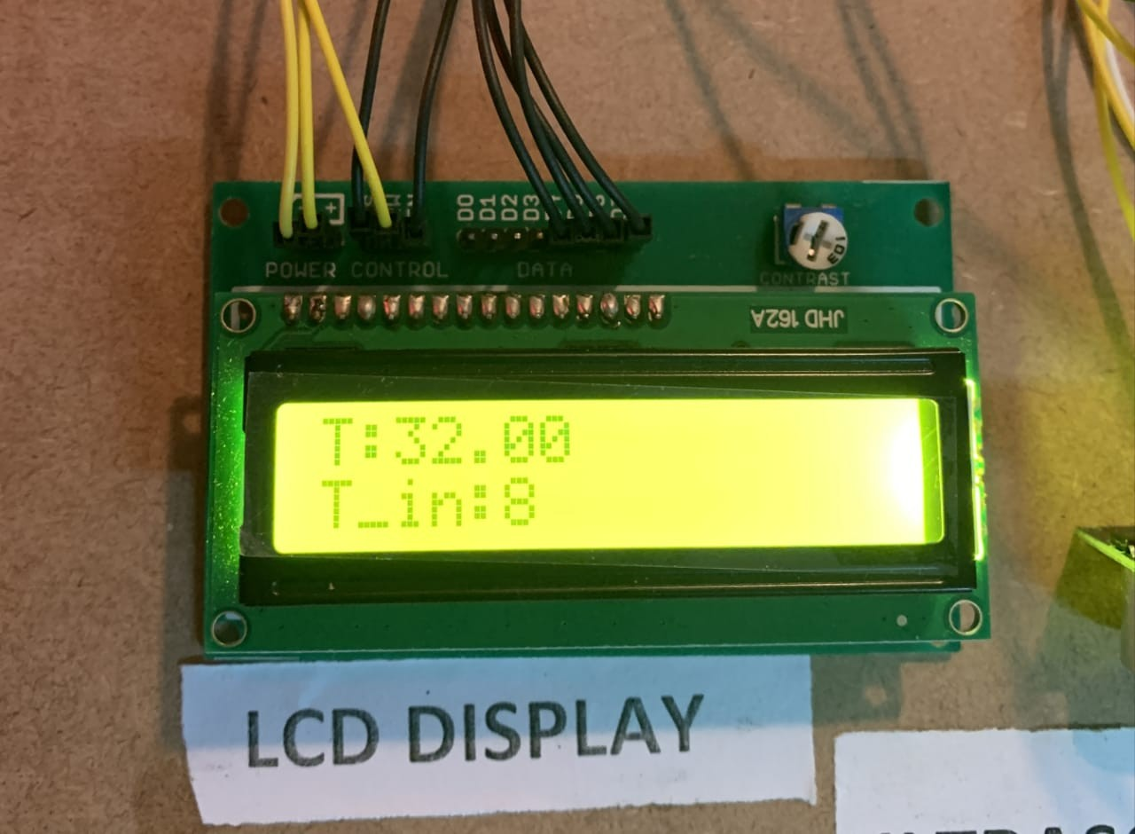 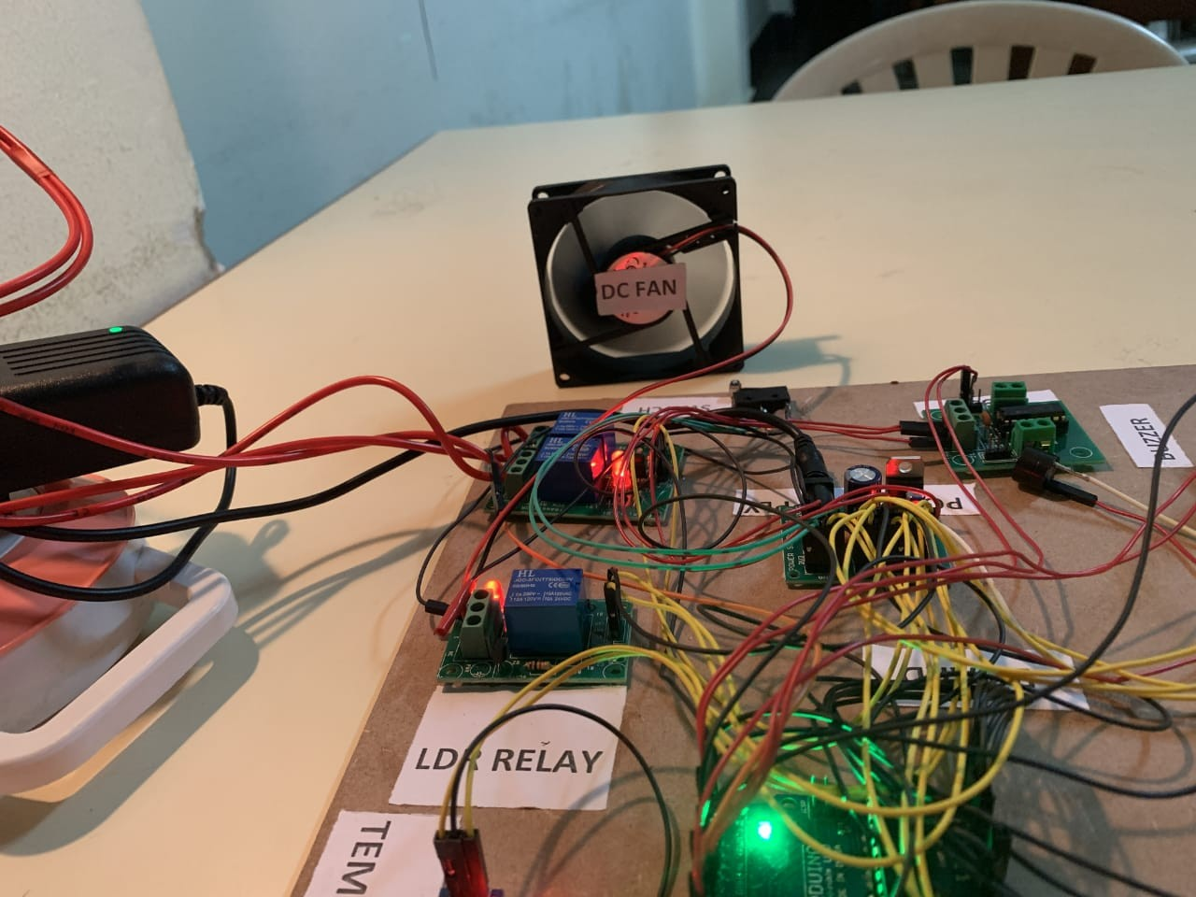

(a) When temperature is greater than 30 degree (b) Fan is ON state

## Automatic board cleaning

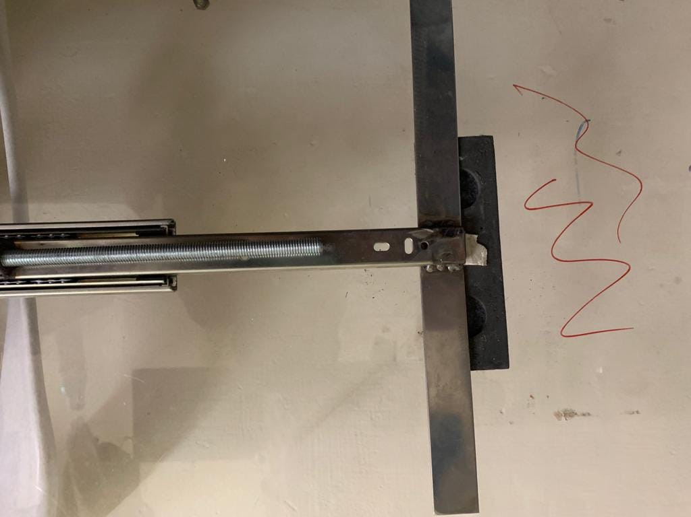

Figure 6.3: Before board cleaning.

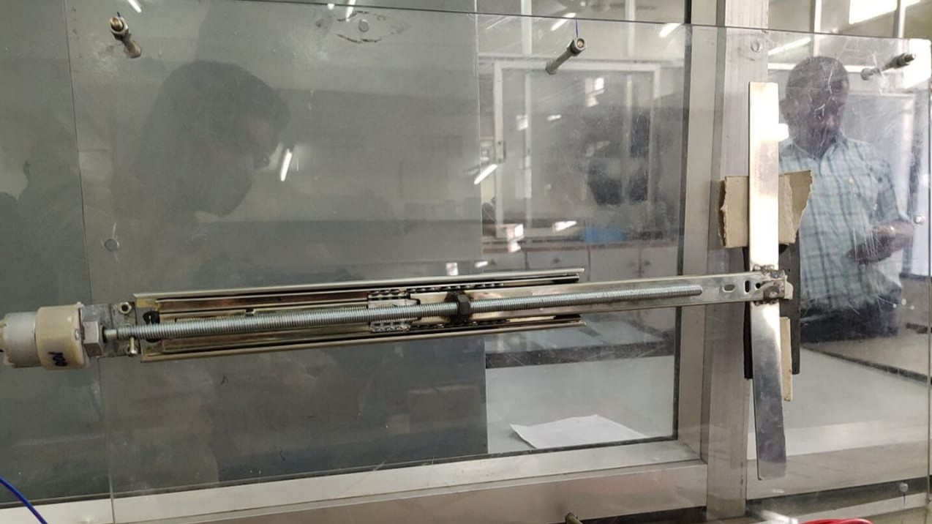

Figure 6.4: After board cleaning.

# Conclusion

A Smart classroom system is designed to monitor and save electricity in the schools, colleges, library, etc. The project titled “Smart classroom” is successfully tested in the library, SIT Tumkur. The device detects the number of persons entering the room and the room temperature with the help of an ultrasonic sensor and temperature sensor to turn ON the lights and fans during working hours, and the whiteboard cleaner cleans the entire board automatically with just a button click at any time whenever necessary. The proposed system is an efficient, inexpensive solution for real-time power saving and monitoring.

## 7.1 Scope for future work

Bio metric Student attendance management can be incorporated to take attendance of students.

1. Sumit Chavan , Vishal Shinde , Nikhil Murade , Anjali Jagtap, Varsha Degaonkar, “*Automatic White Board Cleaner* ”, International Journal of Computer Sciences and Engineering(IJCSE) , vol.7, pp.428, May 2019.
2. Rajesh Shrestha, “*Study and Control of DHT11 Using Atmega328P Microcontroller* ”, International Journal of Scientific Engineering Research , vol.10, pp.518, April 2019.
3. Abhishek Madhukar Barewar, “*Fabrication of automatic screw jack* ”, International Journal of Advance Research and Development , vol.3, pp.64, April 2018.
4. Geethika Kilari, Rizwana Mohammed and Ramesh Jayaraman, “*Automatic Light In- tensity Control using Arduino UNO and LDR*”, International Conference on Commu- nication and Signal Processingt, vol.3, pp.862-866, July 2020.
5. Yashaswini N, Raghu N, Yashaswini S, Prathib Kumar G, “*Automatic Street Light Control by Detecting Vehicle Movement* ”, IEEE International Conference on Recent Trends in Electronics, Information Communication Technology, pp.847-850, May 2018.
6. Dr. Haider Kadhim Hoomod1, Sadeem Marouf M. Al-Chalabi, “*Objects Detection and Angles Effectiveness by Ultrasonic Sensors HC-SR04* ”, International Journal of Science and Research (IJSR), vol.6, pp.918, June 2017.
7. Siddharth Remane, Radhika Sutar, Pranav Joshi, Digambar Patil, Yogesh Naik, “*Au- tomatic light switching and temperature based fan speed control using microwave, tem- perature and LDR sensor* ”, International Research Journal of Engineering and Tech- nologyy (IRJET), vol.8, pp.360, May 2021.

# Appendices

**Appendix A**

# Data Sheet of Arduino

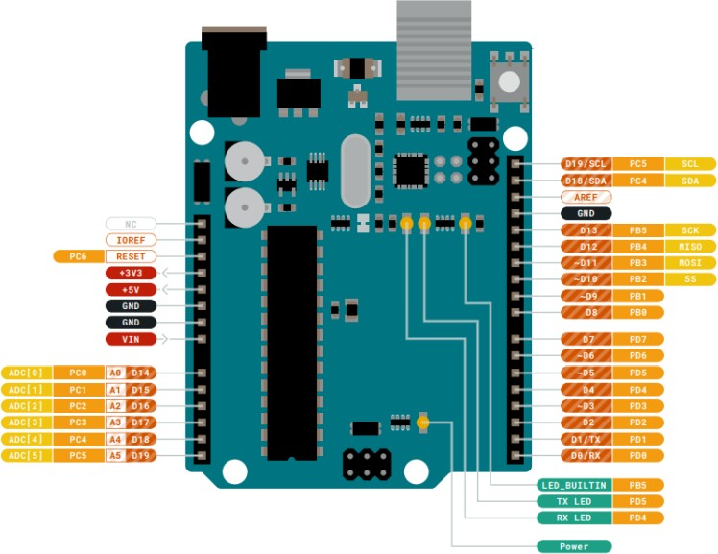

Figure A.1: Arduino UNO.

Microcontroller: ATmega328P Operating Voltage: 5V

Input Voltage (recommended): 7-12V Inout Voltage (limit): 6-20V

Digital I/O Pins: 14 (of which 6 provide PWM output) PWM Digital I/O Pins: 6

Analog Input Pins: 6

Smart Classroom 2021-22

DC Current per I/O Pin: 20 mA DC current for 3.3V Pin: 50 mA

Flash Memory: 32 KB of which 0.5 KB used by bootloader 16 KB ISP Flash

512B EEPROM

512B SRAM

debugWIRE interface for on-chip debugging and programming Clock Speed: 16 MHz

Length: 68.6 mm

Width: 58.4 mm

Weight: 25 g

# DataSheet of Relays

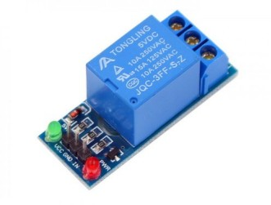

Figure B.1: Relays.

Supply voltage – 3.75V to 6V Quiescent current: 2mA

Current when the relay is active: 70mA

Relay maximum contact voltage – 250VAC or 30VDC Coil voltage- 12V per channel

Relay maximum current – 10A

# Data Sheet of Ultrasonic Sensor

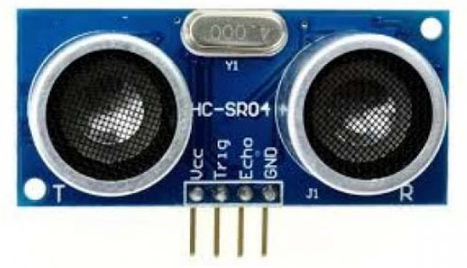

Figure C.1: Ultrasonic Sensor.

1. Supply voltage: 5V (DC).
2. Supply current: 15mA.
3. Modulation frequency: 40Hz.
4. Output: 0 – 5V (Output high when obstacle detected in range).
5. Beam Angle: Max 15 degrees.
6. Distance: 2 cm – 400 cm
7. Accuracy: 0.3cm.
8. Communication: Positive TTL pulse.

# Data Sheet of Motor driver (L293D)

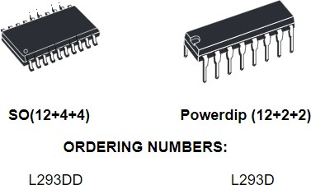

Figure D.1: L293D.

1. Wide Supply-Voltage Range: 4.5 V to 36 V
2. Separate Input-Logic Supply
3. Internal ESD Protection
4. High-Noise-Immunity Inputs
5. Output Current 1 A Per Channel (600 mA for L293D)
6. Peak Output Current 2 A Per Channel (1.2 A for L293D)
7. Output Clamp Diodes for Inductive Transient Suppression (L293D)

# Data Sheet of Buzzer

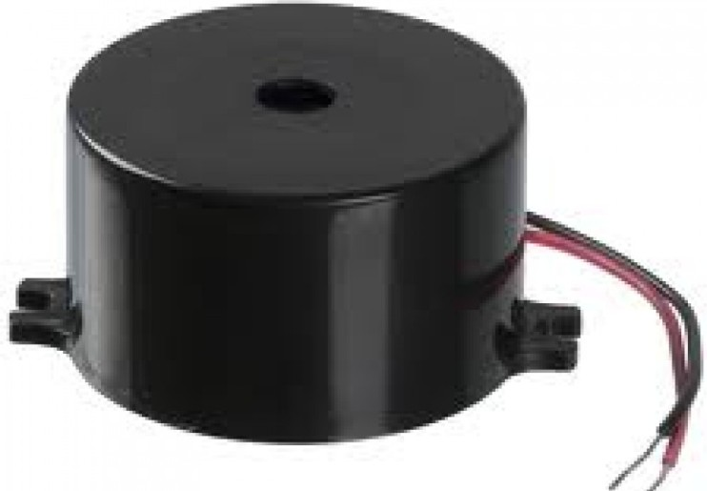

Figure E.1: Buzzer.

Specifications: Rated Voltage : 6V DC Operating Voltage : 4 to 8V DC Rated Current : less than 30mA

Sound Output at 10cm : greater than 85dB Resonant Frequency : 2300 ±300Hz

Tone : Continuous

Operating Temperature : -25°C to +80°C Storage Temperature : -30°C to +85°C Weight : 2g